Hooded Towel Instructions
By Paula Luberts
Wingsical Whims Embroidery
www.wingsicalwhims.com

These instructions are for the general construction of a hooded towel.

Supplies Needed:
(This will make two hooded towels)
2 large bath towels
1 hand towel
Scissors, Pins, Sewing Machine
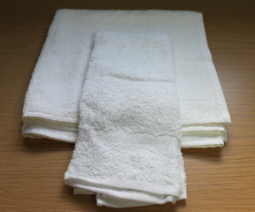
Put one of your bath towels aside for later.

Step One:
Cut your hand towel in half horizontally. This will give you two pieces of your hand towel equally. Set one half of the hand towel aside with the other towel for a later towel.

If you are embroidery on your towel, this is where you would start embroidering before putting the towels together. For Example:
I am making a fox: so I would start embroidery here.
If you are not embroidering but hand embellishing go to Step Two.
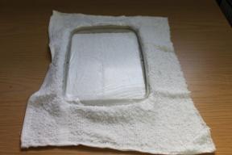
Stitch out as instructed with your embroidery design instructions.
Step Two:
Fold your hand towel (hood) in half, matching the sides together. (Embroidery on the inside if you did this) Pin in place. Sew together I used a ¼ inch seam allowance. The seam will be on the inside; you may cut this to be smaller if you wish. This is the inside of the hood. (I like to do this step second) (I use a serger) Some do this as step 3.

(This is the wrong way if you have something for the outside of the hood.)
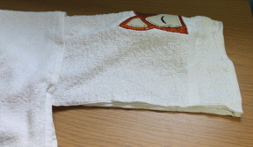
(yes, of course, I did it wrong the first time)

Step Three:
Lay out the large bath towel, and center your half of hand towel on top of the large bath towel. Putting the cut side of the hand towel side up. Now pin the hand towel to the bath towel and sew together.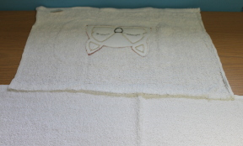
Hooded Towel is complete.
The actual hooded towel takes about 15 to 20 minutes to make.
My completed hooded towel.

