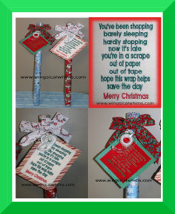
Gift Wrap and Tape Gift
Thank you for purchasing Wingsical Whims Embroidery Designs.
Great for Teachers, Mailman, Garbage Man, Neighbors, Coworkers
and the list could go on.
Not only is this a great gift it is a useable gift and thoughtful gift.
You can choose to embroider the 4 x 4 or the 5 x 7 design/

Materials:
Wingsical Whims Embroidery Design
Felt
Card Stock
Ribbon
Tape
Wrapping Paper
Glue Stick
Hole Punch

- First embroider the sentiment out as you normally would. I used cut a way for stabilizer.
- Cut out design leaving some edges, I left the tear a way on for easier gluing.
- Pick out your card stock. Put the embroidered design on the card stock and determine where you would like your edges. I left about a ½ inch around the design. I also cut both the card stock and the paper with my fancy edge scissors. (they are really called pinking shears) Cut both.
- I used a Glue stick to glue the card stock to the embroidery design. I also had to take the edges of the design and glue to the cut a way. You could also use a hot glue gun if you would like. Let Dry.
- Punch a hole in the corner with your hole punch.
- Add a ribbon to the hole, add your tape and wrap around the tube of the wrapping paper. Tie so it is tight. Add another bow if you wish.
- Don’t forget to sign the bottom with your name so they know who it has come from.
Written by Paula Luberts
Wingsical Whims Embroidery
www.wingsicalwhims.com

